**Lab 4.1**

The original given code displays the following:

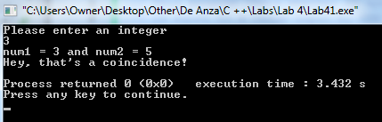

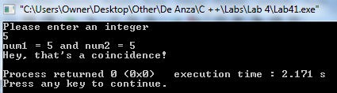

The code has a mistake. It states that num1 and num2 are equal even when they aren't. The assignment operator "=" in line 23, is supposed to be "==", and equality operator. So I fixed it and now I have this output:

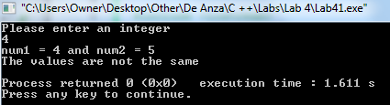

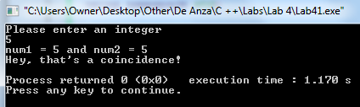

*Modify the program so that the user inputs both values to be tested for equality. Make sure you have a prompt for each input. Test the program with pairs of values that are the same and that are different.*

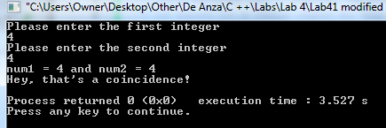

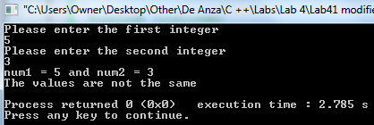

*Modify the program so that when the numbers are the same it prints the following lines: The values are the same. Hey that's a coincidence!*

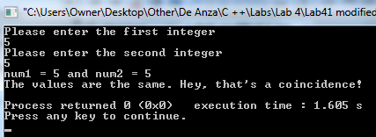

*Modify the revised program earlier by replacing the two if statements with a single if/else statement. Run the program again to test the results. Take a screen shot of the output.*

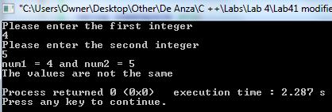

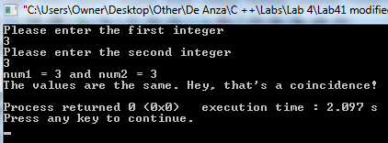

END